關於 PL2303HX 在 win8 無法驅動的問題

http://yhhuang1966.blogspot.tw/2015/07/pl2303hx-win8.html

為了給 Arduino Pro mini 灌程式, 今年 4 月在露天買了一條蠻好用的 PL2303HX USB-TTL 程式上傳線 (價格便宜 & 板子有封裝), 在 XP 或 Win7 安裝官網所下載的 1.8.0 版驅動程式都可以抓到 com port, 上傳都 OK, 參考 :  
  
# [安裝 PL2303HX USB 轉 TTL 驅動程式](http://yhhuang1966.blogspot.tw/2015/04/pl2303hx-usb-ttl.html)  
# [PL2303HX 下載線 USB轉TTL 長1米 UART Arduino Pro mini 可](http://goods.ruten.com.tw/item/show?21452084146591)  
  
但是這條 PL2303HX 線一直無法被家裡的聯想桌電 Win8.1 與我的 Inhon Win8.1 筆電抓到 (錯誤代碼 Code 10 : 無法啟動此裝置), 所以我向賣家詢問是否無法在 Win8.1 系統使用, 其回答如下 :  
  
"可以在win8使用，但要注意、Win8系統自帶的驅動程式均不支援PL2303HX， 必須要關閉Win8的驅動程式自動更新，請自行下載2009年以前的驅動程式才可正常使用哦！"  
  
我也在谷歌搜尋到好幾個解答, 但其實都沒有啥用 :  
  
# <https://drive.google.com/file/d/0BzdGbZCSZTdsdTh4dTFmUEF1bzQ/view>  
# [Prolific PL2303 USB-to-Serial port adapter driver fails to install](http://answers.microsoft.com/en-us/windows/forum/windows_vista-hardware/prolific-pl2303-usb-to-serial-port-adapter-driver/1902e9e0-4af0-4f36-84bc-f487d4022f1f?auth=1)  
# [win8 PL2303驱动的问题(已经解决掉了),有问题的同学可以参考](http://tieba.baidu.com/p/2378715876)  
# [PL2303 Prolific USB to TTL Driver for Windows 8.1](http://ananddrs.com/2014/09/24/pl2303-prolific-usb-to-ttl-driver-for-windows-8-1/)  
  
最後找到這個外國人的解答, 這才了解為何露天賣家說要找 2009 年以前的驅動程式安裝才行, 原來這條上傳/下載線裡面的晶片可能是仿製的 (原文用 Fake, 假冒的), 所以原廠旺玖科技 Prolific 已經在新版的驅動程式中封殺此類晶片, 參見 :  
  
# [FAKE PL2303 – HOW TO INSTALL ON WINDOWS 8.1](http://wp.brodzinski.net/hardware/fake-pl2303-how-to-install/)

"A quick investigation gave an unpleasant anwser – PL2303 chips are fake!  
In the newest drivers Prolific blocked all fake chips and the driver in Windows 8.1 is also blocking my fake pl2303. But there is a solution – you have to install old drivers – version 3.3.2.105."  
  
我照文中建議方法, 去下載 2009 年以前的驅動程式 :  
  
# [IO-Cable_PL-2303_Drivers-Generic_Windows_PL2303_Prolific](http://wp.brodzinski.net/wp-content/uploads/2014/10/IO-Cable_PL-2303_Drivers-Generic_Windows_PL2303_Prolific.zip)  
  
解開後執行其中的 PL2303_Prolific_GPS_1013_20090319.exe, 但這只是把驅動程式複製到系統裡, 還必須做更新驅動程式的動作, 才能把黃色驚嘆號去掉, 讓系統抓到 com port :

[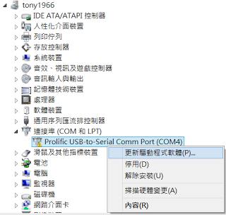](http://2.bp.blogspot.com/--mplGz1Ob-8/VahnoZc3XQI/AAAAAAAAEGE/ZN-rmwG5tJM/s1600/PL2303HX-1.png)

選下面那個 "瀏覽電腦上的驅動程式軟體" :

[](http://3.bp.blogspot.com/-gFvx78wgZTY/VahoJQESMII/AAAAAAAAEGM/7E0bKld0nMk/s1600/PL2303HX-2.png)

還是一樣選下方的 "讓我從電腦上的裝置驅動程式清單中挑選"

[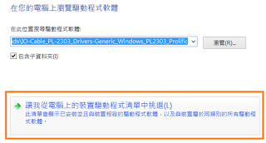](http://2.bp.blogspot.com/-Jp9af1LrdDo/VahogHc8TdI/AAAAAAAAEGU/5GU-TfqytbA/s1600/PL2303HX-3.png)

挑選剛剛安裝的那個 3.3.2.105 版驅動程式 (2008/10/27) :

[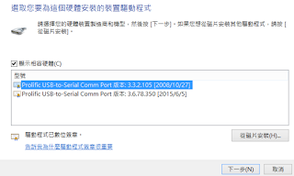](http://1.bp.blogspot.com/-8oDhdZ4BH5M/Vaho5mAVUjI/AAAAAAAAEGc/9_d8gXDj0BU/s1600/PL2303HX-4.png)

再按下一步, 跑完 "正在安裝驅動程式軟體" 後, 即可抓到 com port 了 :

[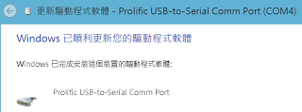](http://2.bp.blogspot.com/-GD1R9Sl61hY/VakUqlUgo1I/AAAAAAAAEGw/_fLwFckz20o/s1600/PL2303HX-5.png)

驚嘆號三角形消失, 大功告成.  
  
關於 USB-TTL/UART 轉接線問題, 高手葉難寫過一篇很完整的文章, 詳見 :  
  
# [Raspberry Pi：透過序列埠登入系統](http://yehnan.blogspot.tw/2013/09/raspberry-pi.html)  
  
20150722 補充 :  
  
我量了 TXRX 線輸出為 3.3V (VCC 輸出為 5V), 似乎可用在 ESP8266 (但電源必須用 AMS1117 電源模組輸出的 3.3V 才夠力), 參考 PL2303HX 的 PDF 規格書,  
  
# <http://www.prolific.com.tw/UserFiles/files/ds_pl2303HXD_v1_4_4.pdf>  
  
在 "3.0 Introduction" 中有提到可連接 3.3v 設備 :  
  
" Flexible signal level requirement on the RS232-like serial port side also allows PL-2303HXD to connect directly to any 3.3V~1.8V range devices."  
  
20150622 補充 :  
  
我在露天找到這款可支援 Win10 的 PL2303TA 晶片的下載線, 要 88 元, 我當初買 PL2303HA 的才 34 元! 其實有網友照上面程序在 Win10 安裝 2008 年驅動程式 OK, 我今天也來試試看.

<http://wp.brodzinski.net/hardware/fake-pl2303-how-to-install/>

[01Paź 2014](http://wp.brodzinski.net/hardware/fake-pl2303-how-to-install/)

# FAKE PL2303 – HOW TO INSTALL ON WINDOWS 8.1

by [BartB](http://wp.brodzinski.net/author/admin/" \o "by BartB)

I recently bougth two USB-to-UART converters with Prolific PL2303 chip inside. I found them on [Aliexpress](http://www.aliexpress.com/wholesale?SearchText=pl2303&catId=0&initiative_id=SB_20141001121708" \o "Aliexpress) in a really good price (0.89$ each).  
After waiting 3 weeks, they finally arrived.  
[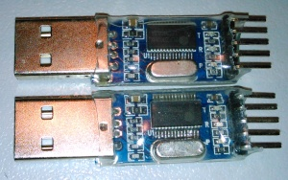](http://wp.brodzinski.net/wp-content/uploads/2014/10/DSC_0177-e1412195451606.jpg)  
  
But unfortunately I didn’t read enough about converters with these chips before buying. As it turned out converters are recognized in Windows 8.1 as Prolific-to-Serial Comm Port but marked with yellow warning sign.  
[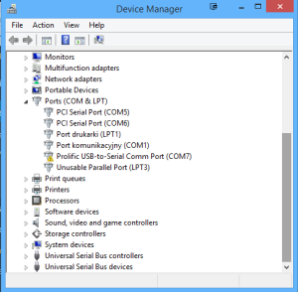](http://wp.brodzinski.net/wp-content/uploads/2014/10/pl2303_warn.png)  
Putty is constatly giving an error „Unable to open connection”. In addition in the device propperties I found an error

|  |  |
| --- | --- |
| 1  2 | This device cannot start. (Code 10)  A device which does not exist was specified. |

[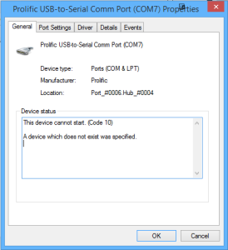](http://wp.brodzinski.net/wp-content/uploads/2014/10/pl2303_error_code.png)

*Error code 10.*

A quick investigation gave an unpleasant anwser – PL2303 chips are fake!  
In the newest drivers Prolific blocked all fake chips and the driver in Windows 8.1 is also blocking my fake pl2303.  
But there is a solution – you have to install old drivers – version **3.3.2.105**.

[IO-Cable_PL-2303_Drivers-Generic_Windows_PL2303_Prolific](http://wp.brodzinski.net/wp-content/uploads/2014/10/IO-Cable_PL-2303_Drivers-Generic_Windows_PL2303_Prolific.zip)

Simply install drivers, then go to **Device Manager**-> Right click on**Prolific-to-Serial Comm Port** and select**Update Driver Software…**.  
In **Update Driver Software**window chose: **Browse my computer for driver software**-> **Let mi pick from list of devices on my computer**, Select **Prolific USB-to_Serial Comm Port version 3.3.2.105 model [10/27/2008]** from model list and click next.

[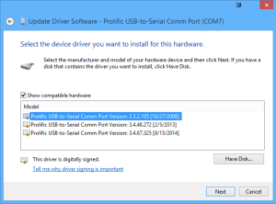](http://wp.brodzinski.net/wp-content/uploads/2014/10/pl2303_driver.png)

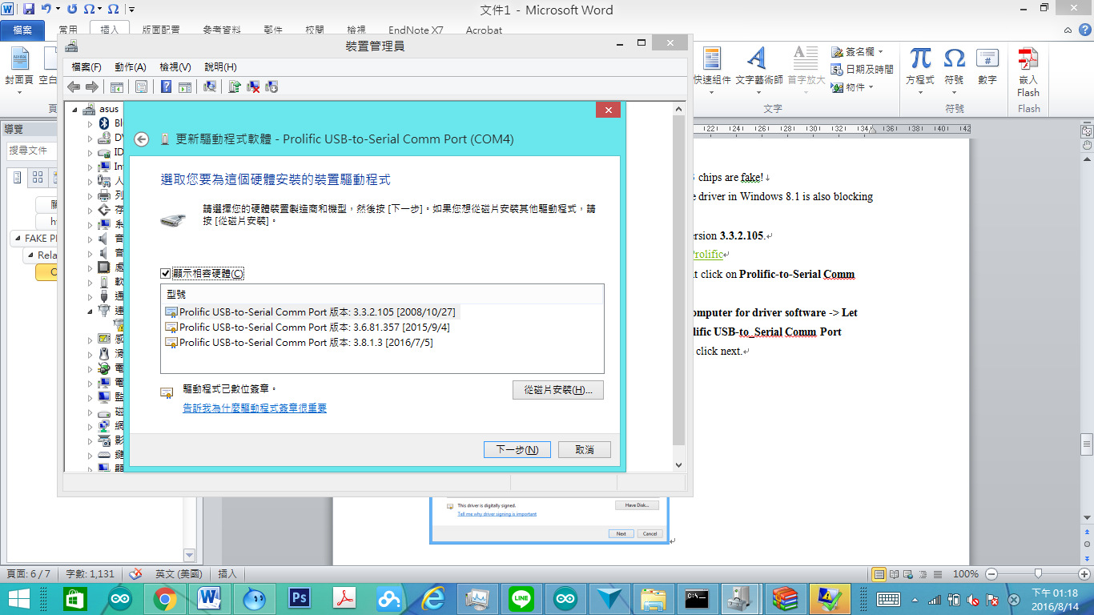

*USB-to-Serial Comm Port Driver.*

The driver will install and your fake pl2303 Prolific converter will be ready to use ;)

## Related links:

<http://7er.pl/showthread.php/22428-Sterowniki-do-RS232-PROLIFIC-PL2303-Win7-x64>  
<http://grylewicz.pl/kabel-usb-rs232-prolific-pl2303-i-blad-kod-10/>

Posted in: [Hardware](http://wp.brodzinski.net/category/hardware/) ⋅ Tagged: [pl2303](http://wp.brodzinski.net/tag/pl2303/), [uart](http://wp.brodzinski.net/tag/uart/), [usb-to-serial](http://wp.brodzinski.net/tag/usb-to-serial/)

### One Thought on “Fake PL2303 – how to install on Windows 8.1”